Under the supervision of:

**Ms. Priya Dhoundiyal**

INTERNSHIP REPORT

Submitted by:

**Kushagra Gupta**

**DECLARATION**

I, Kushagra Gupta, hereby declare that every project done in this industrial training is original work and has not been published or submitted to this organisation or any other institution for any academic award.

Date: ………………………

i

**ACKNOWLEDGEMENT**

The completion of any inter-disciplinary project or task depends upon cooperation, co-ordination and combined efforts of several sources of knowledge. I am grateful to **Ms.Priya Dhoundiyal** for her willingness to give me valuable advice and direction whenever I approached her with a problem. I am thankful to her for providing me with immense guidance throughout this internship.

I would also like to thank **Mr. Ishan Agarwal** Sir for giving me the opportunity to pursue internship in this company.

Mentor:

**Ms Priya Dhoundiyal**

ii

**ABSTRACT**

I carried out my internship at Climbax Entertainment Pvt. Ltd. From May 28,2019 to July 8,2019. Climbax aims to bridge the gap between the real and the virtual world by developing customized solutions in the field of virtual reality, 2D/ 3D Animations, VFX, software, Mobile App and Web development, Films and media and digital marketing and it offers internship to the students who are in need of education about the same. Internship is an opportunity to relate what has been covered in the class and what is applicable in the practical life. The purpose of the program is to fulfill the core equipment for the award of Bachelor degree in technology to get a practical aspect of the theoretical work.

During my internship period, a number of approaches and exposure methods were used which included: hands on, through reading relevant materials, and also questions and answers approach.

I was assigned to the Tech division of Climbax Entertainment Pvt Ltd. I gained knowledge of HTML, CSS, PHP and JavaScript.

In conclusion, this was an opportunity to develop and enhance skills and competencies in my career field which I actually achieved.

iii

**TABLE OF CONTENTS**

Declaration i

Acknowledgment ii

Abstract iii

Table of contents iv

Week 1 1

Week 2 3

Week 3 4

Week 4 6

Week 5 10

Week 6 12

Conclusion 14

iv

**WEEK 1**

I started my internship programme learning [HTML](https://developer.mozilla.org/en-US/docs/Learn/HTML) from Mozilla Developer Network Docs and referring W3 School. I covered topics like elements, attributes, headings, paragraphs, styles ,links, images, tables, lists, blocks, classes, Id and forms. To test my knowledge and understanding so far, I designed a website using just <h>, <ul>, <a>, <form>, <input> and <img> tags.

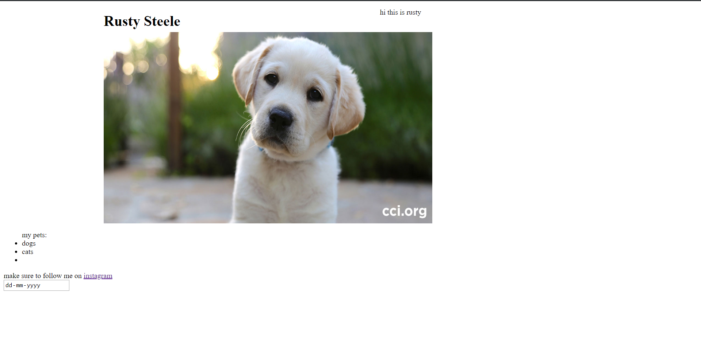

Then I went ahead with learning [CSS](https://developer.mozilla.org/en-US/docs/Learn/CSS/Introduction_to_CSS) from MDN covering topics like basic syntax writing and embedding of cascading style sheets, Targeting elements(selectors), colors, backgrounds, borders, margins, padding, box model and formatting text using CSS.

1

Advancing with topics like CSS positioning, tables, flexbox and grids from MDN, I made a ‘tic-tac-toe’ game using tables and formatted it using CSS. Also designed a grid test layout and, explored and applied various properties of Grids to it.



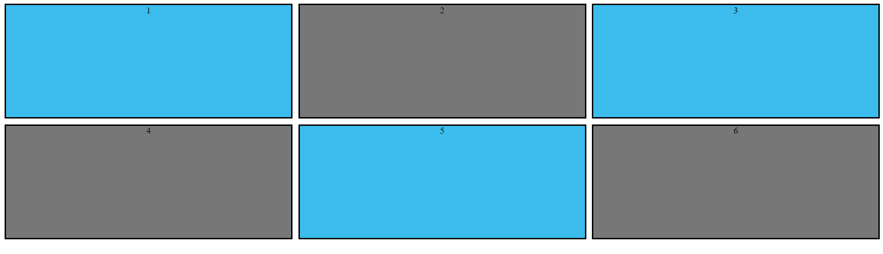

2

**Week 2**

Being advised to follow ‘The Net Ninja’ YouTube channel, I started watching video tutorials from the channel. Covered basic syntax, inline and embedding styles, targeting elements, and selectors. With box models, text formatting, styling links and adding backgrounds, I ended the [CSS for beginners playlist](https://www.youtube.com/playlist?list=PL4cUxeGkcC9gQeDH6xYhmO-db2mhoTSrT) from the channel.

Also covered some advance topics like CSS [Positioning](https://www.youtube.com/playlist?list=PL4cUxeGkcC9hudKGi5o5UiWuTAGbxiLTh) , [Flexbox](https://www.youtube.com/playlist?list=PL4cUxeGkcC9i3FXJSUfmsNOx8E7u6UuhG), and [Grids](https://www.youtube.com/watch?v=d-MHl_Q_hp8) from the channel.

Started with “The Peaky Blinders” project with the help of HTML and CSS. Designed the ‘Home’ and ‘Reviews’ pages in which I added forms and reviews (using <Article> tag of HTML).

3

**WEEK 3**

Continued with ‘The Peaky Blinders ’project; styling Home and Reviews tab of the website.

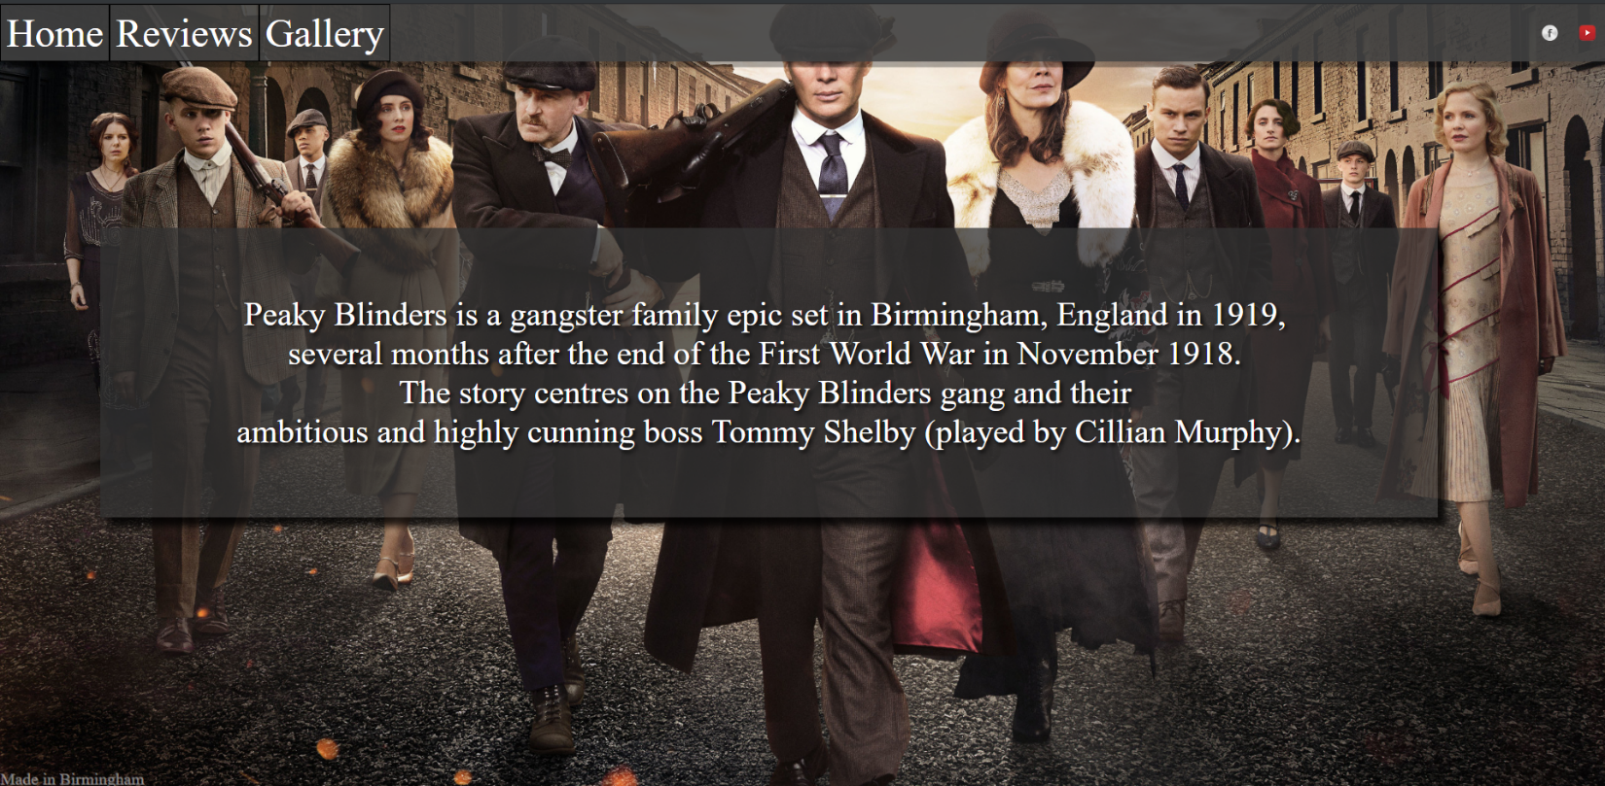

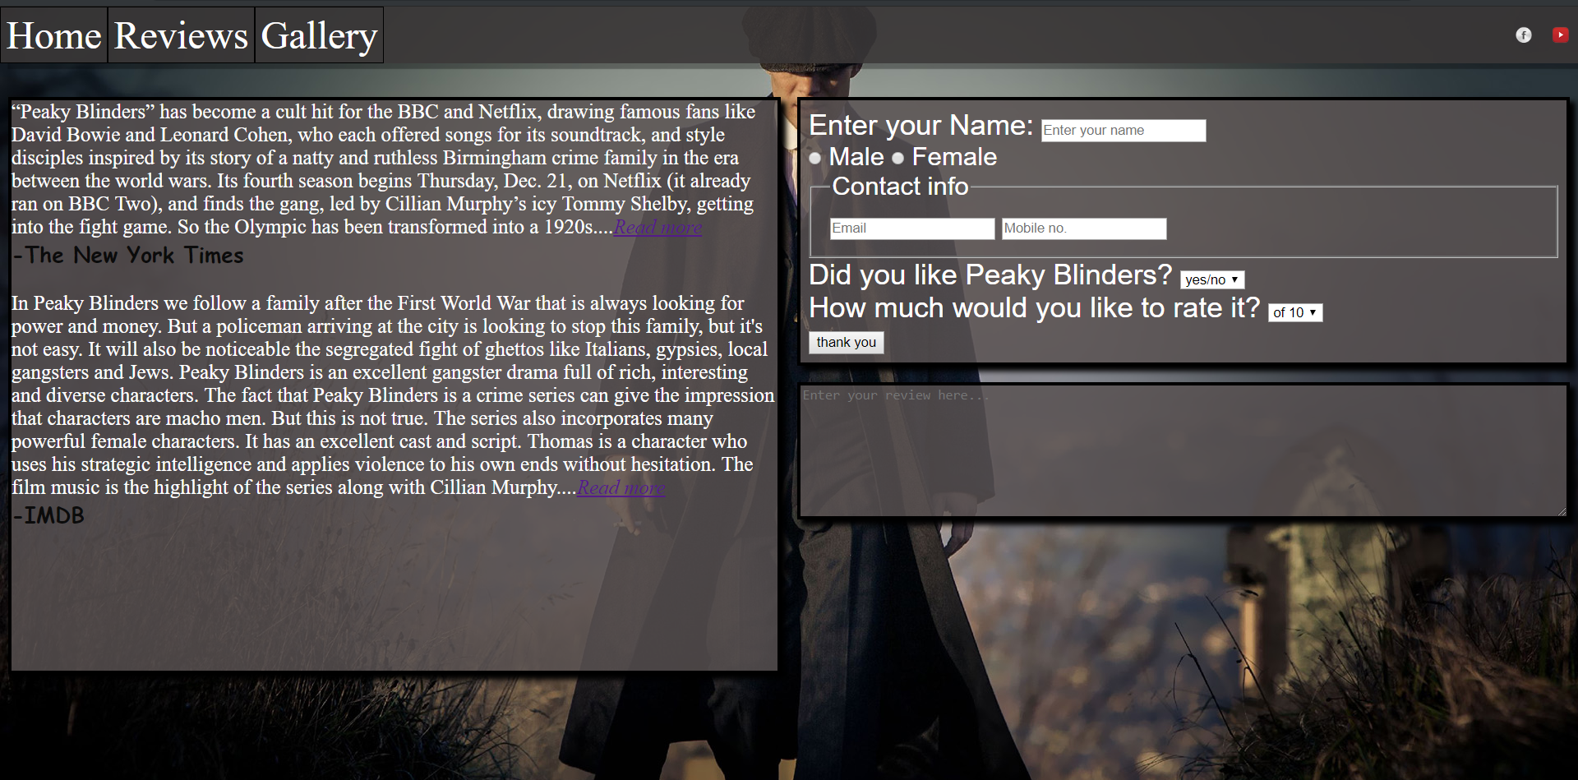

4

Added a ‘Gallery’ page to the website displaying some of the eye-catching images form the TV Series ‘Peaky Blinders’ using flexbox and finalized the project making it responsive.

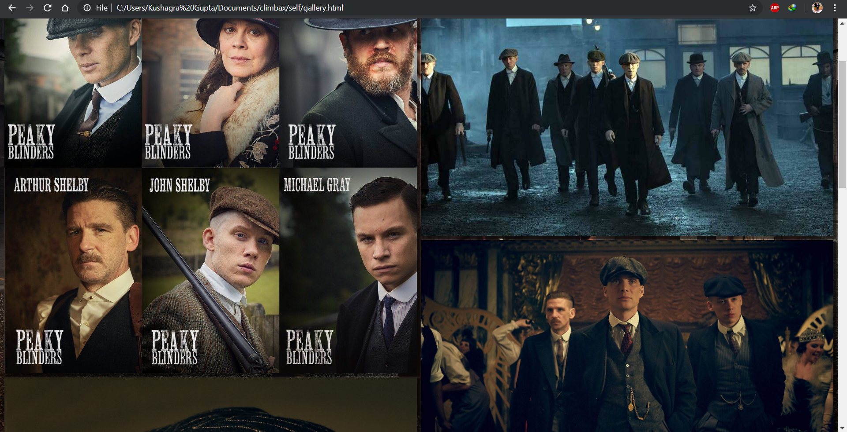

Then I proceeded with exploring bootstrap and other frameworks like Materialize.

Starting with [PHP tutorials](https://www.youtube.com/playlist?list=PL4cUxeGkcC9gksOX3Kd9KPo-O68ncT05o) from The Net Ninja I covered various datatypes, Booleans and conditional statements in PHP. I also learnt form validations, filters and setting up MySQL databases.

5

**Week 4**

Started with “ninja pizza” project along with video tutorials from ‘The net Ninja’ learning MySQL Database Handling.

Firstly, designed the index page using HTML, CSS and Materialize.

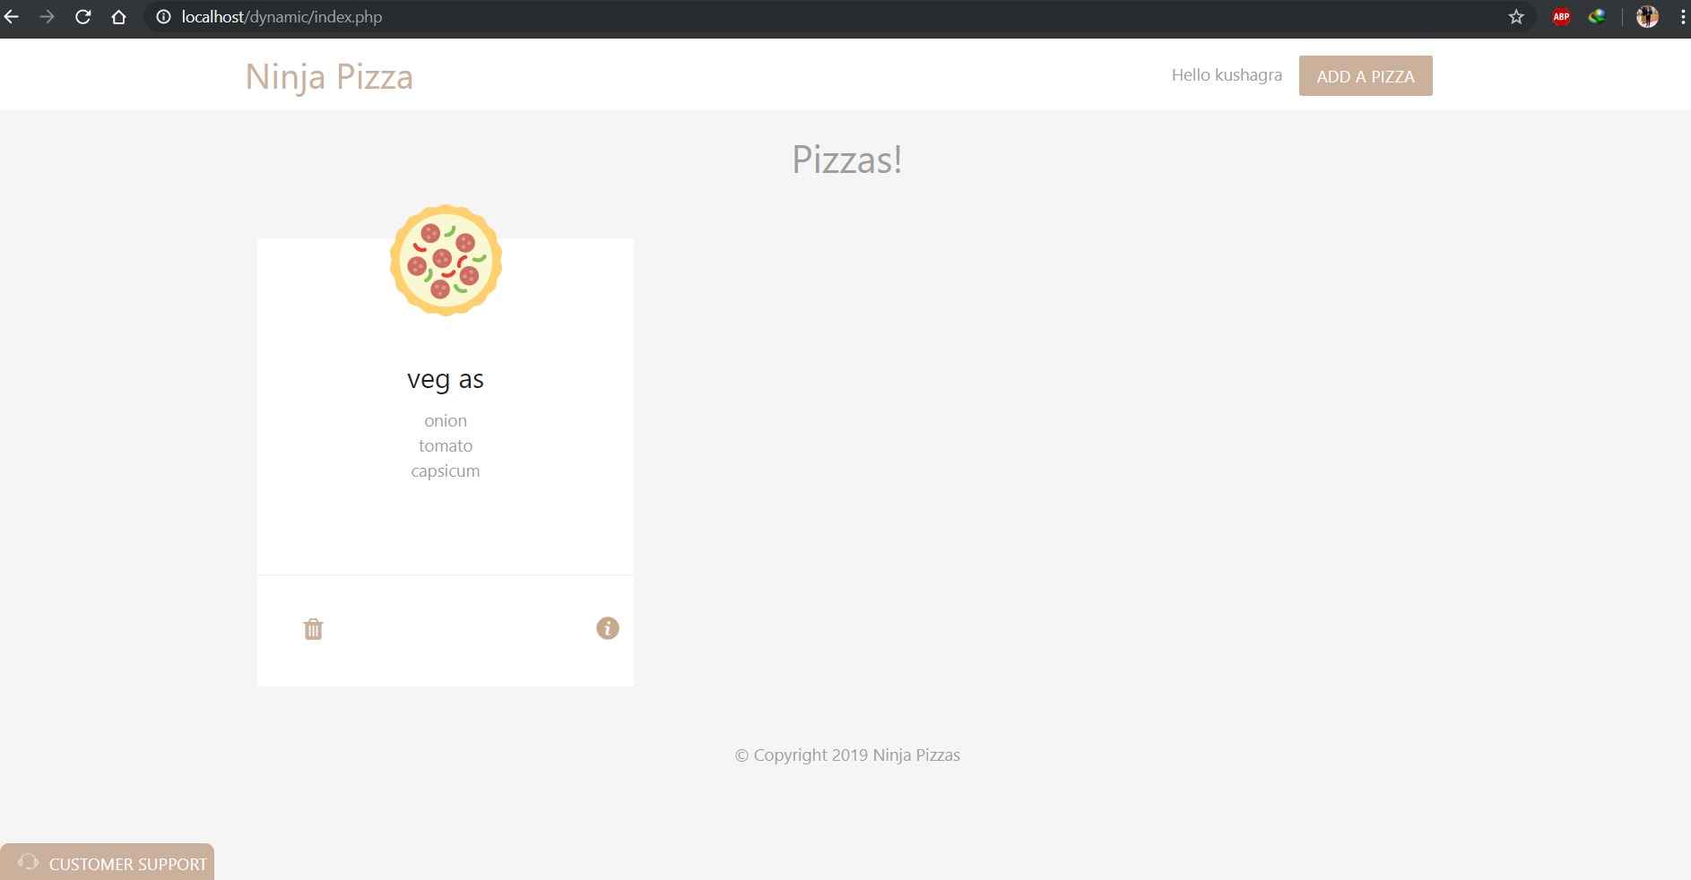

Then added ‘Add a Pizza’ page to the website. Applied form validations and error display functionalities to the page using PHP. Set up a MYSQL Database ‘ninja_pizza’ and created a table named ‘pizzas’ to store the ‘Ingredients’ input by the user while ‘adding a pizza’.

6

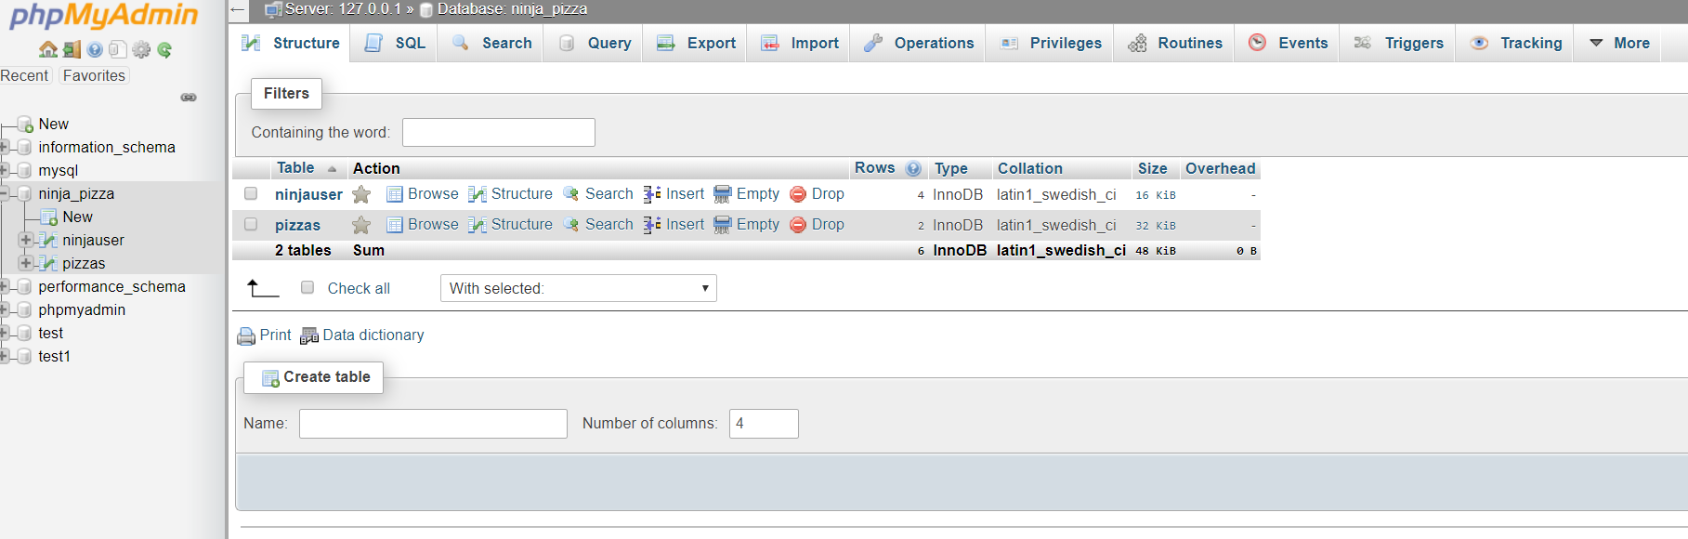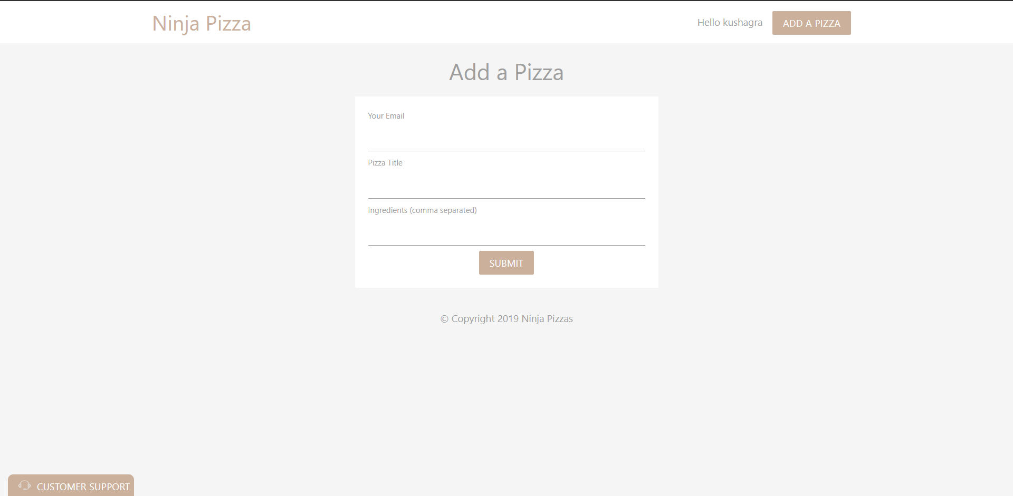

Then added ‘registration’ and ‘login’ pages to the website, styling them with Bootstrap 4 and added a ‘ninjauser’ table to the database ‘ninja_pizza’ to store the credentials of the users logging or registering for the website. Added a username column to the ‘pizza’ table too which gets its value from the $_SESSION variable which started once a user logged in using PHP. This hides the data of users from one another.

7

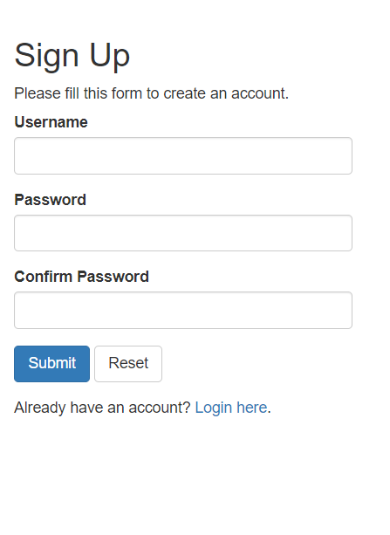

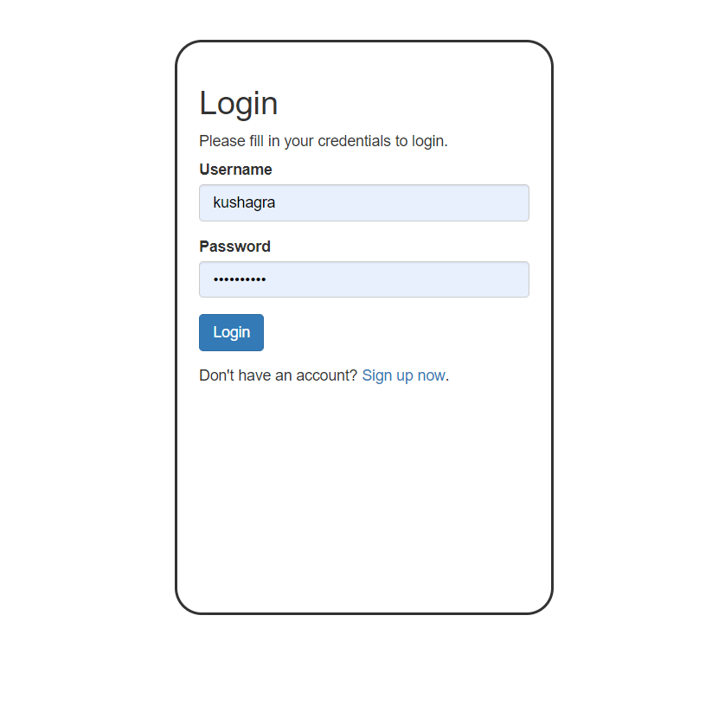

8

Finalized the website by adding a customer support form which supports uploading images (bills in this case). Styled it using Bootstrap 4 and CSS.

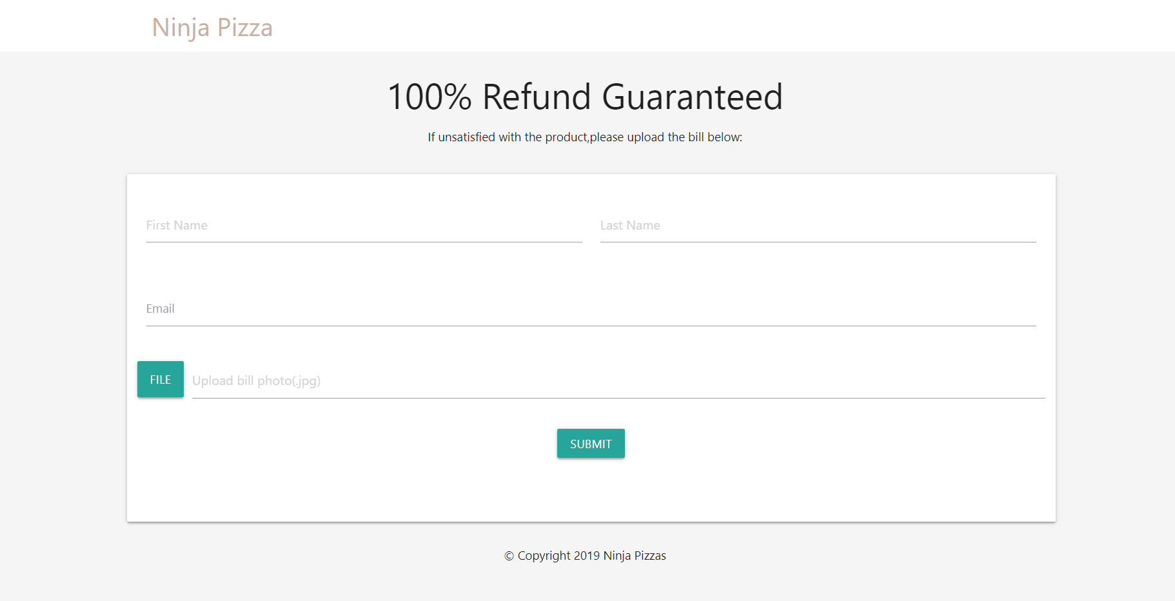

Started exploring WordPress and learnt installing various pre-built themes. Used a preformatted theme to design a news article site.

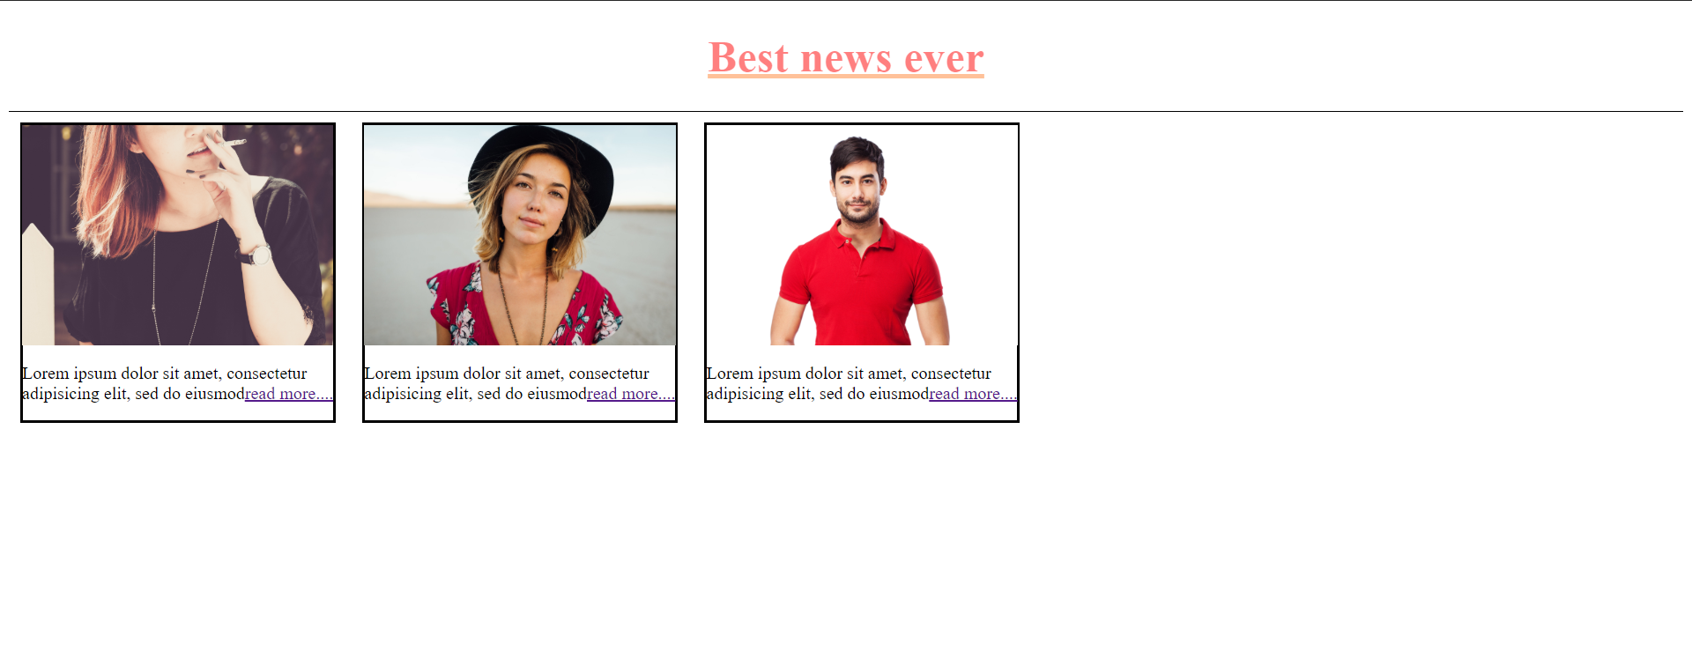

9

**Week 5**

Started with [JavaScript from MDN](https://developer.mozilla.org/en-US/docs/Learn/JavaScript/First_steps) and the [Net Ninja JS for Beginners](https://www.youtube.com/playlist?list=PL4cUxeGkcC9i9Ae2D9Ee1RvylH38dKuET) course.

Covered topics like events, regular expressions, filter methods and, events and

delegations, array’s various methods, date and timestamps.

Applying the knowledge learnt designed a ‘ninja quiz’ which calculates your score on the basis of your answers upon hitting ‘submit’ button. Also animated the display of the score. Also formatted it using Bootstrap 4.

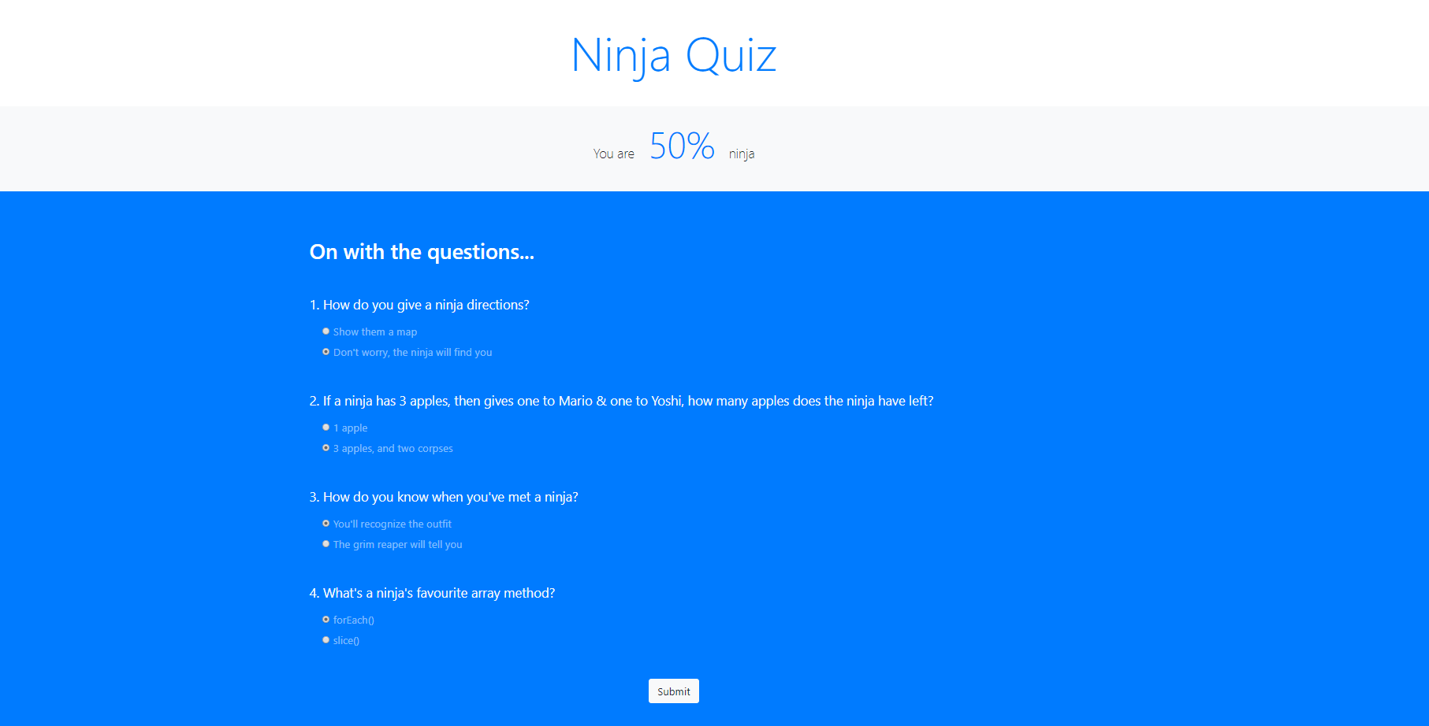

10

Designed a ‘To-Do list’ which offers addition and deletion of items and also allows to search events in the list. This ‘To-do list’ is built using JavaScript and has been formatted using bootstrap.

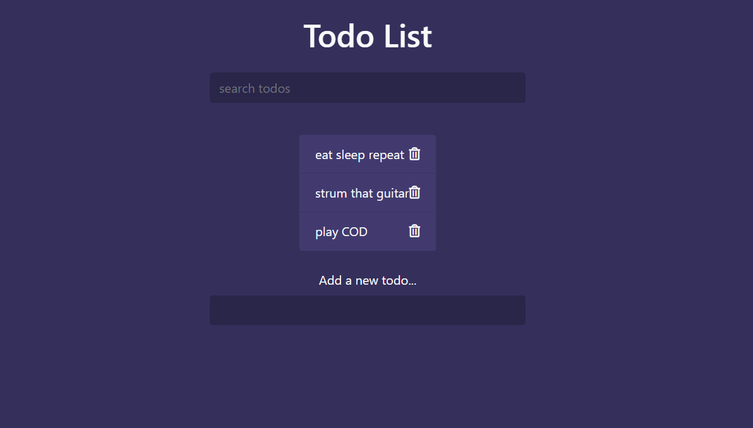

11

**Week 6**

Started with Async part of JavaScript and covered fetching of JSON Data. Also designed a website named ‘AC/DC’ which offers merchandise of the band. You can also filter the items based on categories like Male/Female.

It involves application of HTML, CSS, Bootstrap, PHP and JavaScript.

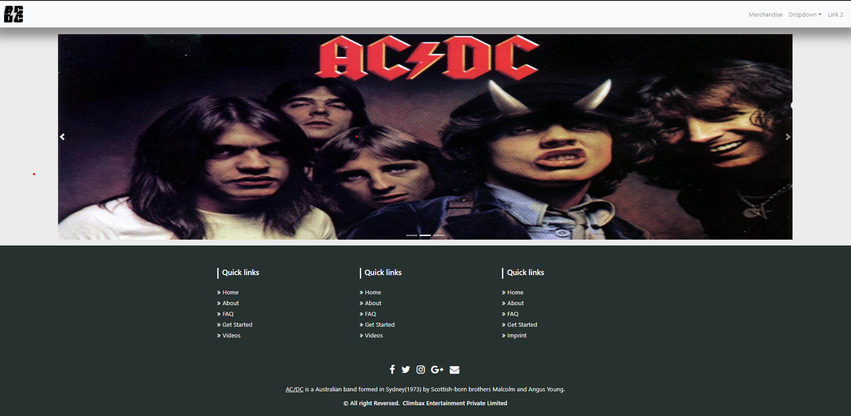

12

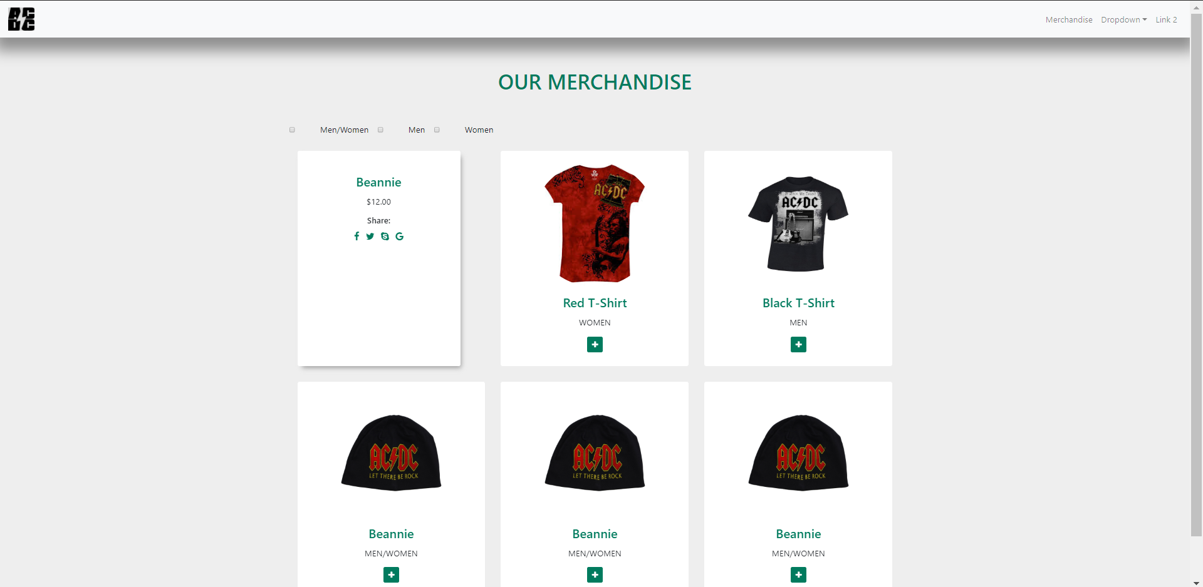

13

**Conclusion**

With the objective of starting with Web Development, I joined Climbax Entertainment Private Limited’ s internship programme to help instil interest for the field in me and to my amazement I have been able to do that. I have learnt HTML, CSS, Bootstrap, PHP and JavaScript. Variation of technologies and frameworks in this field have helped me keep a keen eye towards this field till now and I am sure will adhere to the roadmap to a ‘Full Stack Web Developer’.

I plan to advance and grill myself in JavaScript followed by learning some of the JS libraries like jQuery, Angular and React, and would love to keep working in this field.

14